For Windows:
- Transfer OpenVPN_Server_Windows.zip to the Windows server.
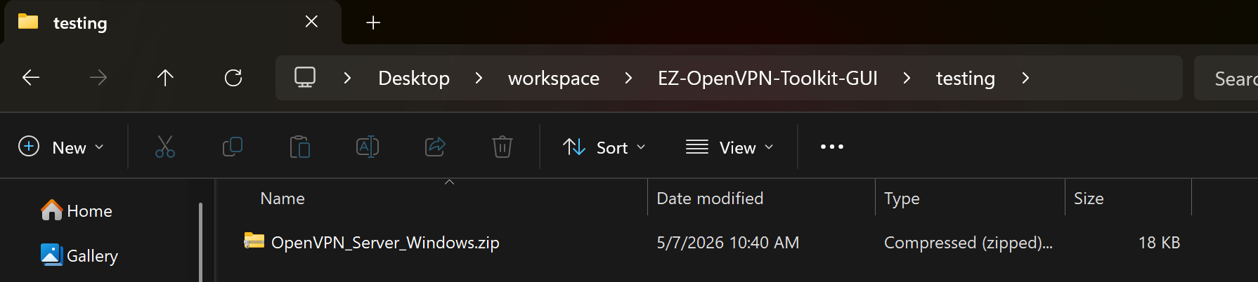
- Extract the zip file to a directory of your choice.
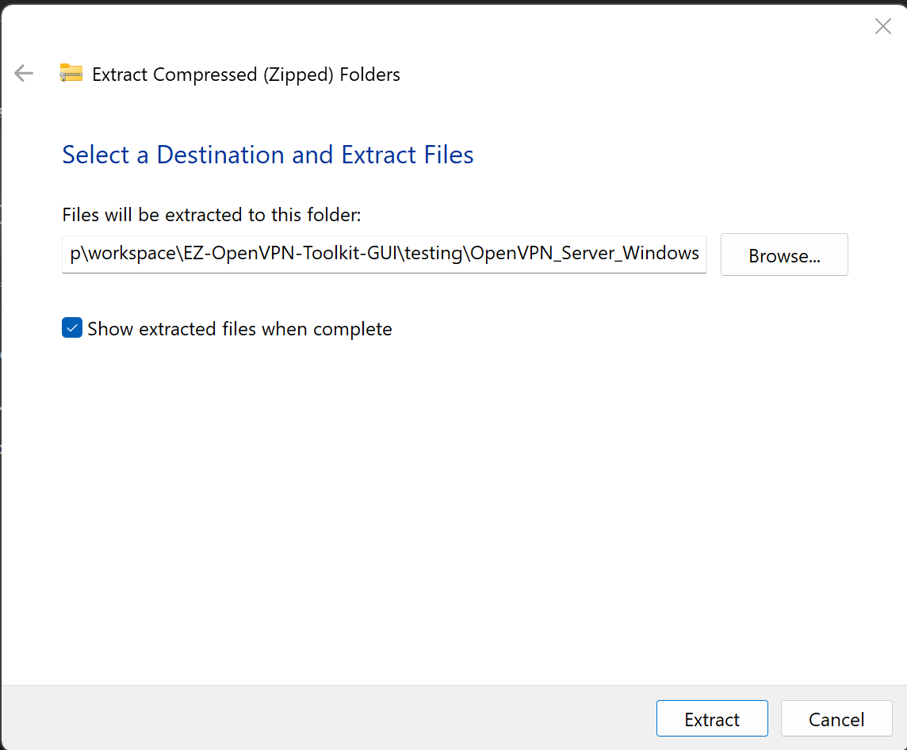
- Open PowerShell as Administrator in the extracted directory and run:
powershell -ExecutionPolicy Bypass -File deploy_ovpn_server_on_win10-11.ps1

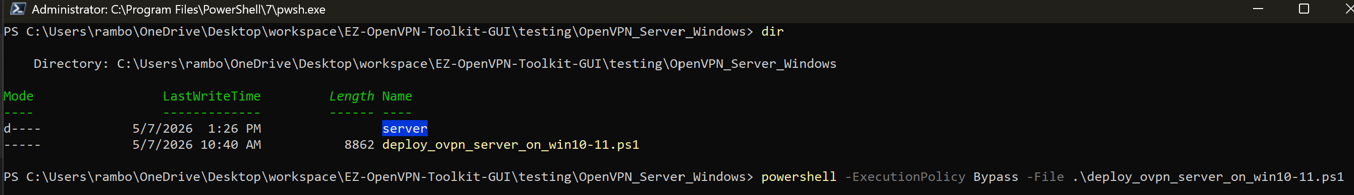

- This process will start the OpenVPN service, enable IP routing, configure Routing and Remote Access, and set up a scheduled task for startup.
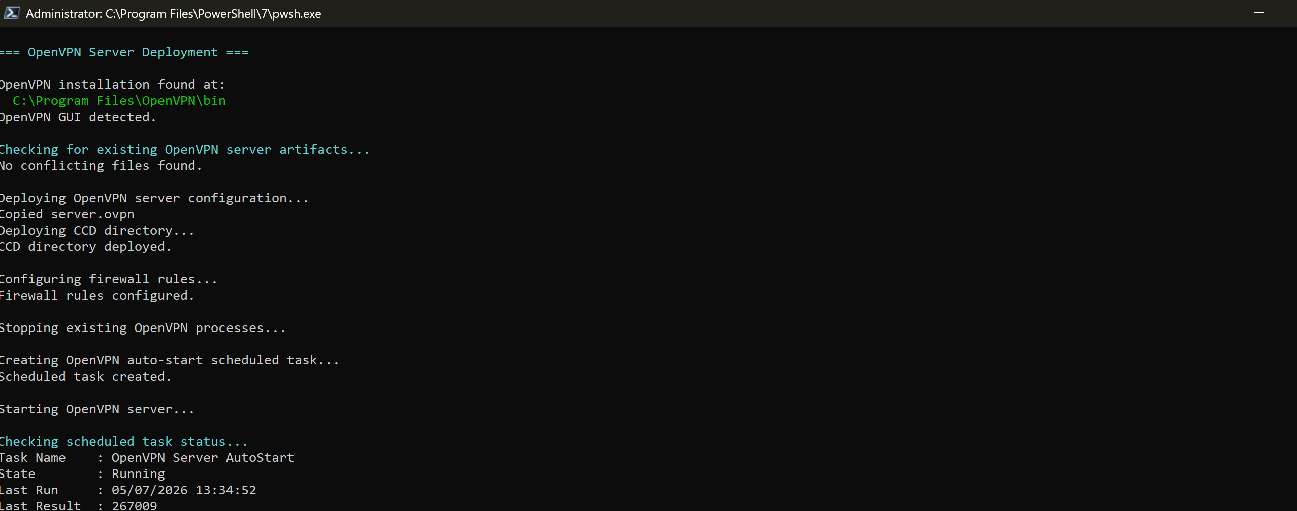
- Once the process is complete you should get confirmation
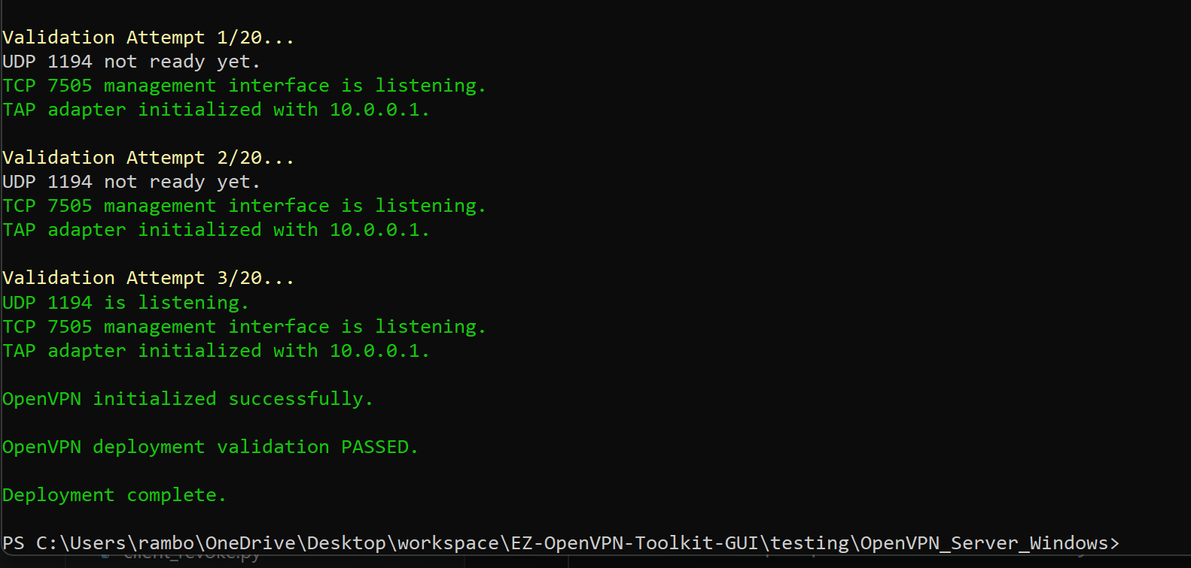
- You can also check manually or after a reboot by running these commands below
